Robot Framework
- Local environment setup guide

First created by Jani Lundan than, Updated and extended by Daniel Siuda

Install Java: 376MB
JRE (Java Run Engine) is enough for Eclipse but test automation (TA) requires
JAVA JDK (Java Development Kit). Go to page JAVA (http://www.oracle.com/technetwork/java/javase/downloads/index.html ) and download newest JDK (Windows x86 = 32 bits and Windows x64 = 64 bits).
Set JAVA_HOME variable
Set JAVA_HOME environment variable to folder where you have installed JAVA JDK for example C:\Program Files\Java\jdk1.8.0_40

Install Eclipse 46MB
Download Eclipse from https://eclipse.org/downloads/
(Install version: Eclipse IDE for Java EE Developers, choose 32 or 64 bit based on installed JAVA version - recommendation is to use 64 bit version if that works in your computer).

Start Eclipse
Start Eclipse and set workspace. To the same folder unzipped TADemo.zip.
Example of folder structure: C:\WORK\TestAutomation\Workspace,
C:\WORK\ TestAutomation\Workspace\TADemo
(Maven project, pom.xml in this folder)

Import TA project to Eclipse
Import test automation project to Eclipse: File / Import → Choose Maven / Existing Maven Project and press Next. Browse path of TA project to 'Root Directory'; example (C:\...\TADemo) then you should see pom.xml in Projects. Select pom.xml and press Finish. Eclipse Package Explorer should contain TADemo project.

Eclipse: configure UTF-8
Configure UTF-8 encoding for Robot framework files.
From Eclipse: Window -> Preferences, then select General -> Workspace. From that view change Text File Encoding to value UTF-8. Click Apply and Close.

Eclipse: configure Java Development Kit
Take installed JDK in use: Window / Preferences → go to view Java / Installed JREs and press Add -button → Choose 'Standard VM' and press Next → browse JDK (Java Development Kit) installation folder to JRE home. JDK will installed to C:\Program Files\Java\jdkX.X.X_XX (or 'Program Files (x86)' in case of 32 bits) by default. Choose defined JDK and press OK. (JRE can be deleted):

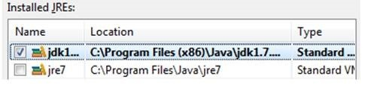
(If configuration is missing there will be error when running test cases: 'Missing artifact com.sun:tools:jar:1.7 pom.xml…

Install Robot plug-in to Eclipse
First way (last time I checked this did not work. You can try but the other way works.)
Complete installation instruction can be found from: https://github.com/NitorCreations/RobotFramework-EclipseIDE/wiki/Installation
In Eclipse Help / Install New Software → Add...
Name: RobotFramework-EclipseIDE
Location: http://sourceforge.net/projects/robotide/files/stable/ press OK and choose 'Robot Framework Eclipse IDE' → Press Next>, accept terms and press Finish.
Second way
go to Help / Install Eclipse market place →
Install "RED - Robot Editor" Wait for status bar to finish installation and restart Eclipse.

File associations in Eclipse:
Window / Preferences → General / Editors / File Associations. Choose *.txt and from 'Associated editors:' window choose 'Robot Framework Text file Editor' and press Default -button.

Set up the Web Driver:
First configure chrome since it's the least problematic. You can setup other browsers later.
Download Chrome Web Driver
http://chromedriver.storage.googleapis.com/index.html
I recommend to create folder Web Driver in your eclipse folder and extract the diver exe here. Also, put there shortcut to page from line above to keep it handy when it needs to be updated.
add that folder to PATH environment variable. (Eclipse needs to be restarted after change)
Download IE Web Driver
http://selenium-release.storage.googleapis.com/index.html
Extract zip and add that folder to PATH environment variable. (Eclipse needs to be restarted after change)
Check that ZOOM=100% and Protected Mode setting needs to same for all zones (Internet option -> Security).

Define Run configuration in Eclipse
From Eclipse: Run / Run Configuration → Choose Maven build and press 'New launch configuration' button, or unfold drop down menu from the (►) icon / Run Configuration
Double click on red "Maven Build" to create new run setting.
Define following (like on the screenshot bellow):
Name: Run case by own TAG (or something else descriptive so that you will remember what that configuration will do), Demo-TA in this example
Base directory: ${workspace_loc:/TADemo} (or other corresponding, to be sure press "Browse Workspace.." button and select project folder)
Goals: clean install
Profiles: (leave empty)
In parameters section press "Add..." button and define:
Name: robot.tag
Value: Demo (Test case containing this TAG will be run with this configuration)
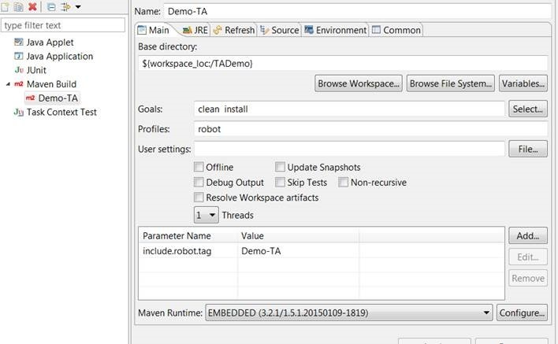

Click on Apply button and Run the window
Console will start running,
Ignore the Charest error (console: Failed to install '': java.nio.charset.UnsupportedCharsetException: cp0.)
In the first run it will download some necessary files,
Then the test should start chrome and continue with defined steps
If it was successful - Congratulation! Your local setup is finished.
Refresh folder TADemo\target (select and F5)
and check the results in TADemo/target/robotframework-reports
check the test files in TADemo\src\main\resources\TestCases
and start playing with the robot on your own.
Make your own test case,
Play with xpath identification
Use it for your purposes.
Hint: Eclipse Robot plug-in will create link from keyword: Press Ctrl and click keyword and Eclipse will open keyword definition.
To start working on some project with synchronized code you would have to set up git but that is different story for another time.

